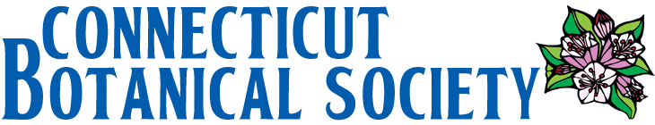

Small Grants Application Form

NOTE: We want to make this application as simple as possible. You may be brief - you don’t even need to use complete sentences - as long as you tell us what we need to know. Click and type at each “_____”. The fields expand within limits. Click on check-boxes.

Applicant Name (organization or person):
Address (City, State, Zip Code):
Contact person (if applicant is an organization) :
Email:
Telephone (and best times):

Project Title:
Amount of Funding Requested:
Brief Description of Project (field expands up to 9 lines):

How does this project meet our criteria for funding up to 5 lines)?
Project Location: Please provide name of property if there is one, and street address or other location aid (map, block, parcel etc.):
Visuals: Please attach property map(s) showing an aerial view, photographs relevant to the project criteria, and any other relevant data or materials that you might have. In the case of long documents, please provide excerpts or a summary rather than attaching the entire document. List attachments here:
Total cost of project:
Expected time of project completion:
Potential sources of additional funding (if needed):
Please attach a SIMPLE budget. You may use the attached (see below) as an example.
Person Responsible for Project Completion: Same as Contact Person on page 1.
If different from the contact person, type name, title, email, phone):
Typed signature of person responsible for project completion:
Email this application and any attachments to: connecticutbotanicalsociety@gmail.com

Simple Budget: Please provide a simple budget for your proposed project, including major categories of costs, total estimated project cost, and total amount requested from CBS. The examples below are intended to show the approximate level of detail we are looking for. You may choose to comment on additional sources of funding, places where project costs are flexible, or other information that may be relevant to the budget.
Example 1: Land Acquisition Project
Category | Items | Cost
Parcel Acquisition | Rare Plant Preserve- Purchase price | $125,000
Fees | Escrow agents, title insurance, transfer tax, property tax, recording fees, attorneys’ fees, etc | $10,000
Total Project Cost |  | $135,000
Amount Requested from CBS |  | $2,000
Comments: We have secured $98,000 in funding for the project so far from private donors and the Local Town Community Foundation.
Example 2: Land Stewardship Project
Category | Items | Cost
Ecological Assessment | Site assessment, mapping, and management plan by a botanical consultant | $1,100
Materials | Brush saw, fencing, flagging, signage | $500
Labor | Reroute trail, fence off sensitive area, cut back competing veg, post signage | $0-500
Total Project Cost |  | $1,600-$2,100
Amount Requested from CBS |  | $2,100
Comments: We would like to hire a student who is majoring in plant sciences, ecology, natural resources, or a related field to complete the labor associated with this project, in keeping with our organization's mission of supporting an up-and-coming generation of conservationists. However, we expect to be able to complete the desired management activities using volunteer labor if funding for a student worker is unavailable.
EXAMPLE BUDGETS

